ULTRALYTICS – MODEL

ULTRALYTICS :
Ultralytics YOLOv8 is a cutting-edge, state-of-the-art (SOTA) model that builds upon the success of previous YOLO versions and introduces new features and improvements to further boost performance and flexibility.

Ultralytics YOLOv8 provides a unified framework for training models for performing object detection, instance segmentation, and image classification. This means that users can use a single model for all three tasks, simplifying the training process

STEP 1: Create the link between Roboflow with Ultralytics using
API key provided in the Roboflow, Copy the API key and paste in the Ultralytics Setting -> Integrations -> Add API key .It creates linked workplace in Ultralytics.

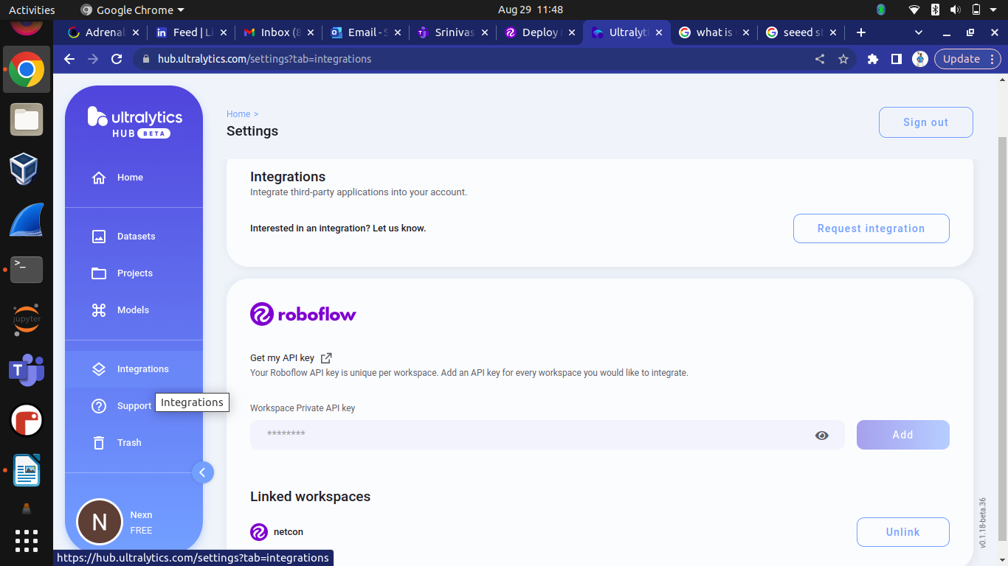
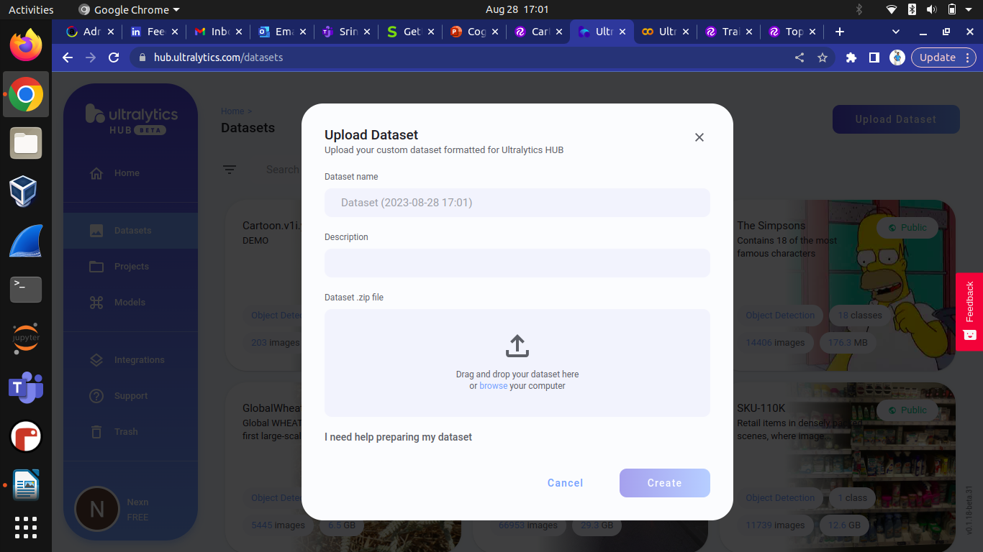
STEP 2 : After the workspace is linked in Ultralytics , Upload the dataset which we downloaded from Roboflow as .zip file.
STEP 3 : While uploading the datasets , you want to select anyone of the model format .(For Ex : Here ,I selected yolov5pytorch)
Then , start training process by clicking on Train Model.

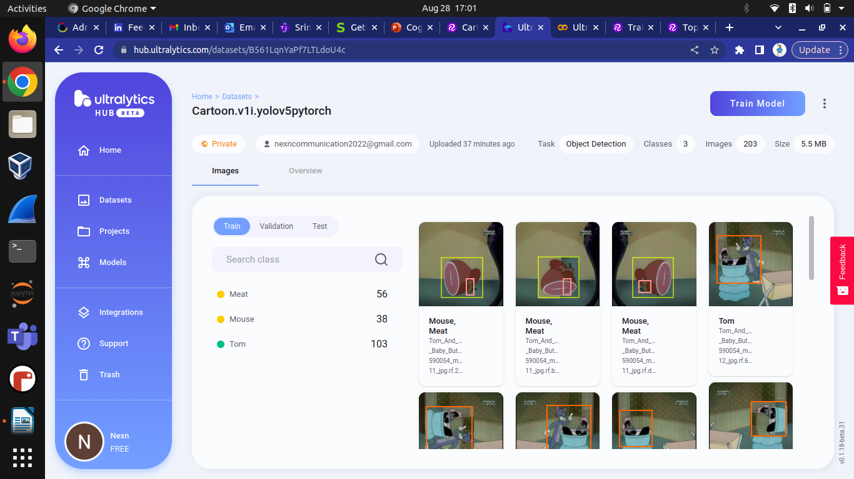

STEP 4 : DATASET

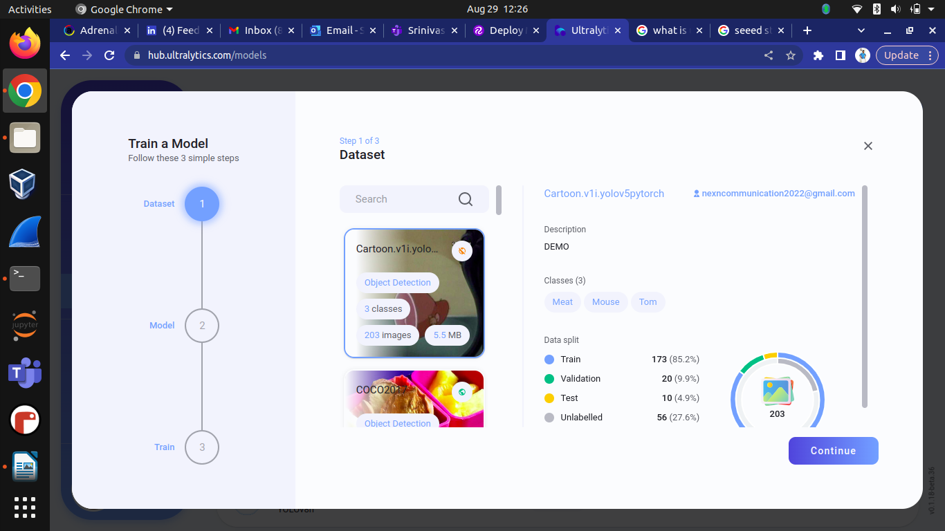
MODEL
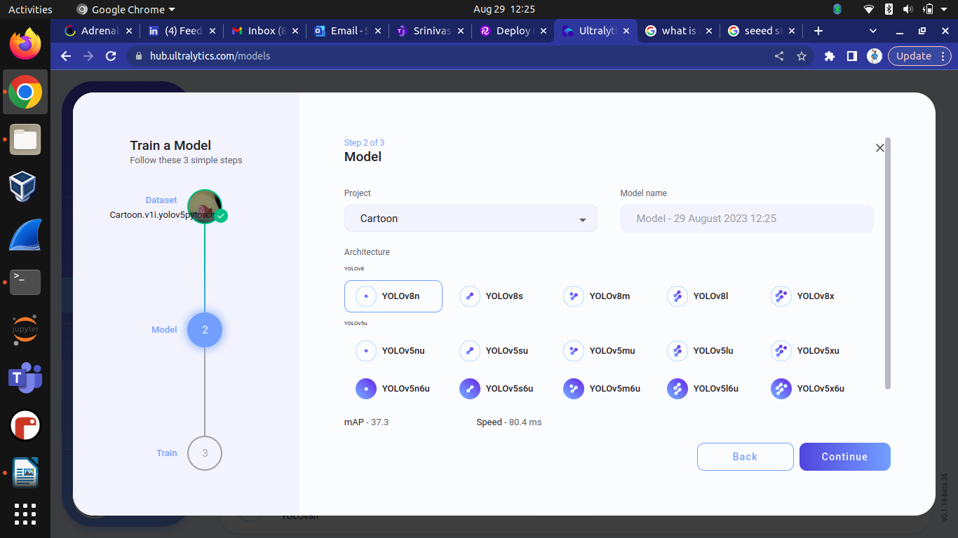
TRAIN
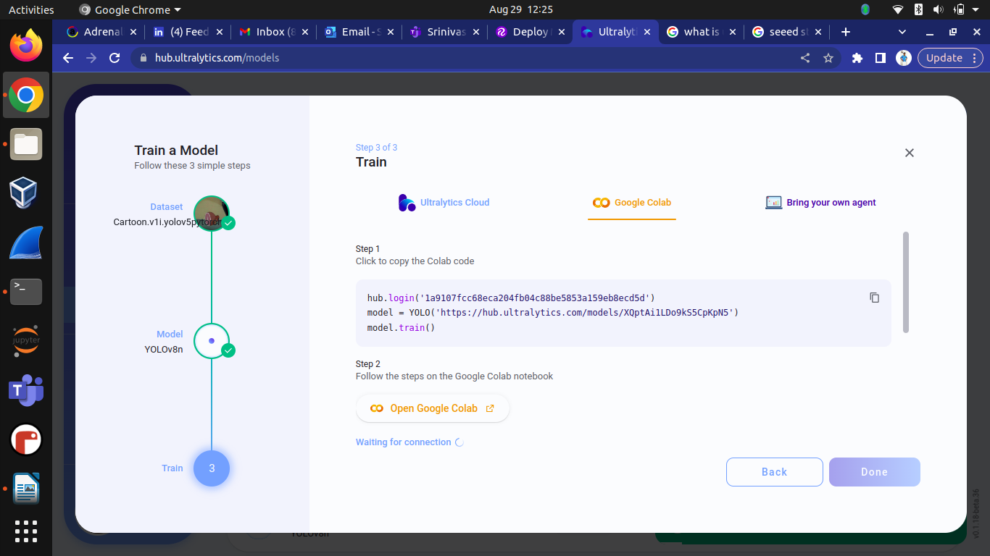

GOOGLE CO-LAB – MODEL RUNTIME
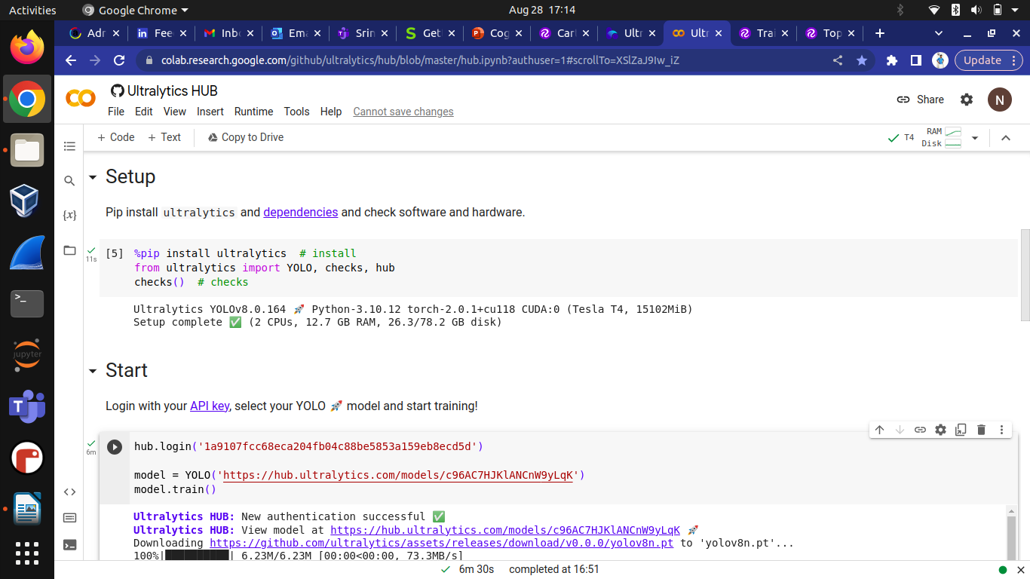
STEP 5 (a) : Copy the code , from the last steps and paste it on the google co-lab and run the code .

STEP 5 (b) : Below output shows ,that the model is successfully
trained and ready for deployment.
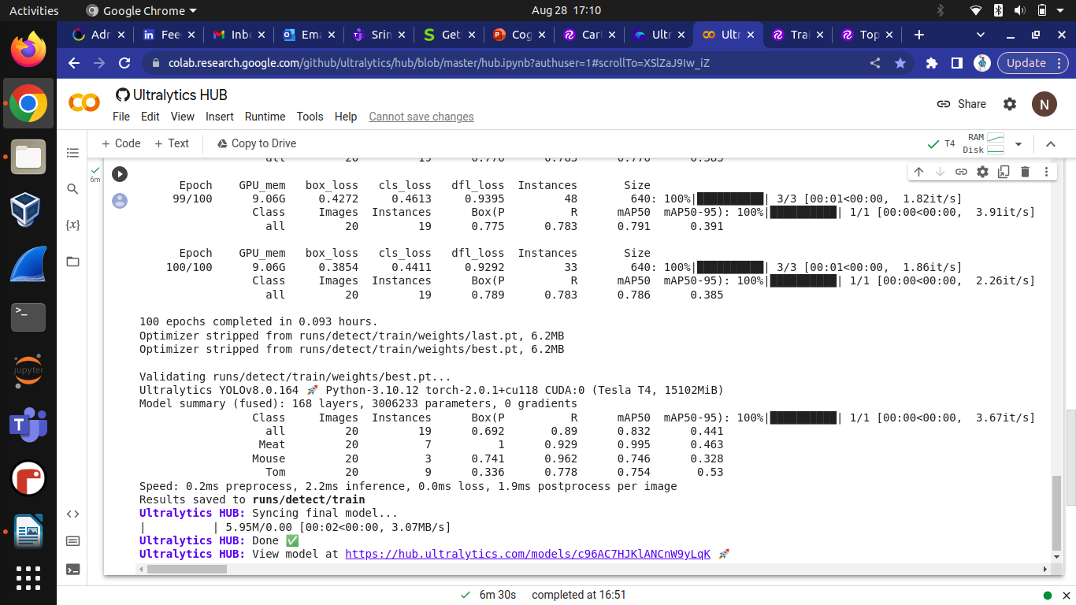
STEP 6 : After code is runs , Model is deployed successfully in Ultralytics

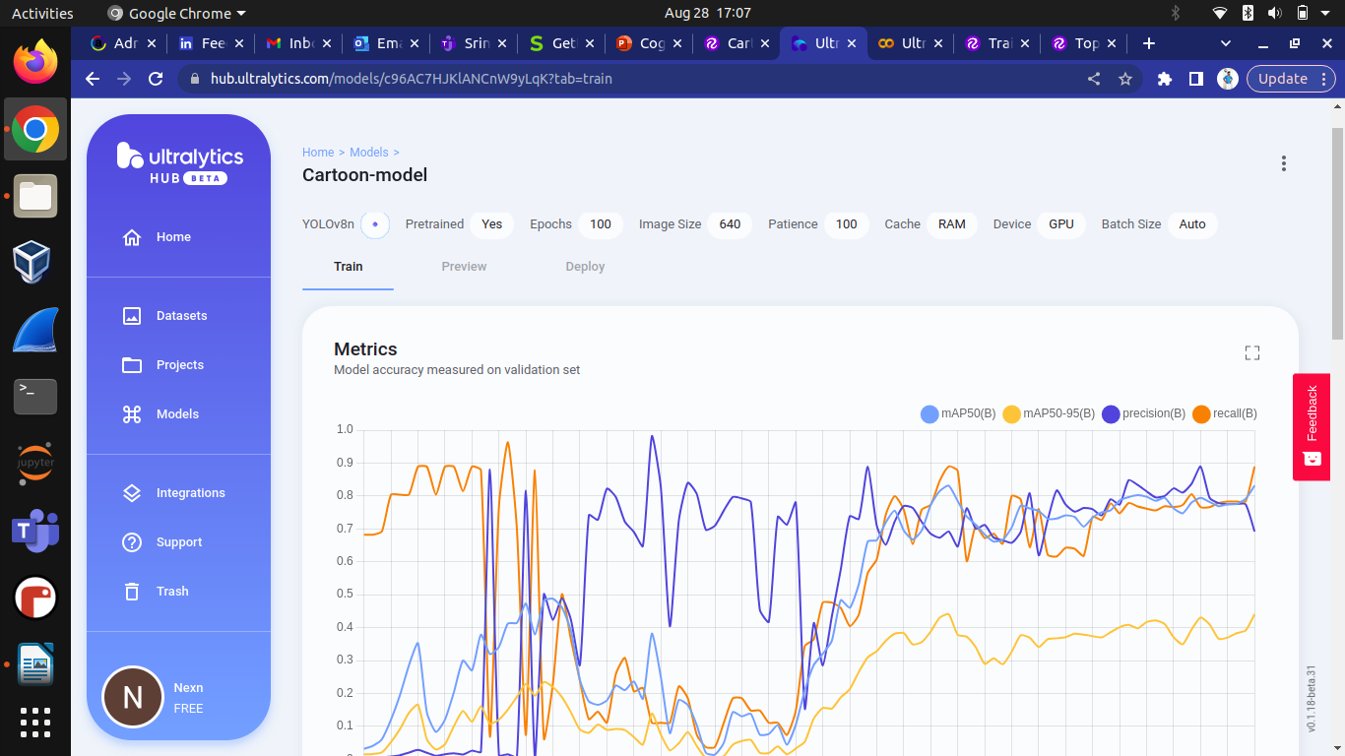
STEP 7 : Test the model using the images.

